Evolutionary game theory

Dr. Jason Noble
jn2@ecs.soton.ac.uk

Outline

- What do we mean by "game"?
- Brief introduction to game theory.
- An example game: the Prisoner's Dilemma.
- Representing games: matrices and trees.
- Solving games via Nash equilibria.
- Using game theory in evolutionary biology.
- A biological example: the Hawk-Dove game.
- Evolutionarily stable strategies and mixed-strategy equilibria.
- The replicator dynamics.
- Other aspects of evolutionary game theory: advantages over traditional theory, repeated games, spatial games, etc.

What is a game?

- Strategic interaction between two or more players that has consequences for all.
- Everyday examples: chess, poker, Monopoly, rock-paper-scissors.
- Economics: rival petrol station owners deciding what to charge per litre.
- Biology: a young male chimpanzee deciding whether to challenge the alpha male for access to females.

A coordination game

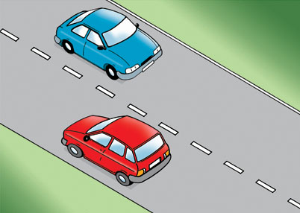
- Two cars approach each other at high speed on a two-lane road.
- Each driver must decide whether to stay to the left or the right.
- If both choose left, or both choose right, they pass safely.
- If one chooses left and the other right, there is a crash.

- In the UK, this game is handled via the social convention of driving on the left.
- Note that this kind of problem is different to optimizing against the environment (e.g., finding the shortest route, designing a more streamlined aeroplane) because the optimal strategy depends on what your opponent will do.

History of game theory

- Ideas mentioned as early as Plato: soldiers considering whether to fight or flee.
- Important in the political philosophy of Thomas Hobbes (1651): the social contract.
- Formalized by John von Neumann and Oskar Morgenstern (1944).
- Hugely influential during the Cold War: the doctrine of "mutually assured destruction".

Maximizing utility

- To get started, we need to know how each agent ranks the outcomes of a game, i.e., its preferences.
- In the coordination game, for instance, it's assumed that we all prefer passing safely to crashing.
- Even better if we can score game outcomes on a single dimension: utility.
- In psychological contexts, this roughly equates to happiness. In economic contexts, it could be money.
- In biological applications utility maps very well to fitness.

The Prisoner's Dilemma
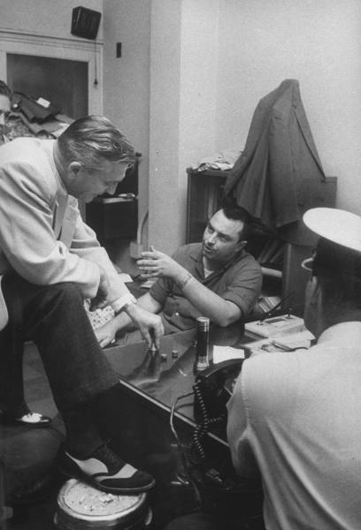

- Two people have been arrested for a robbery.
- The police don't have enough evidence to convict them for the robbery, but can get them for theft of the getaway car (2 year sentence).
- Both are questioned in separate rooms.
- Each is offered the deal "testify against your partner, and you can go free."

- But if they both betray each other, they'll both go to jail (5 years).
- If one betrays the other, the partner gets 10 years and they go free.
- "Do I trust my partner to keep quiet, then we both get only 2 years, or do I betray him, hoping he won't betray me, and try to go free?"
- Here is their utility function:
  - Go free = 4 units (most preferred option).
  - 2 years in prison = 3 units.
  - 5 years in prison = 2 units.
  - 10 years in prison = 0 units.
- What should they do?

Representing the game as a matrix

 | Defect | Cooperate
Defect | (2,2) | (4,0)
Cooperate | (0,4) | (3,3)

- Also called the normal-form or strategic-form representation.
- Player one's strategy determines the row; player two's strategy determines the column.
- Payoffs written as (P1, P2) or sometimes just as P1 if symmetrical.

Representing the game as a tree

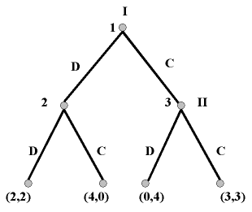

- Nodes represent decision points, labelled by player.
- Terminal nodes represent game outcomes.

- The normal-form loses some detail and implies simultaneous decision-making.
- The extensive form spells out the sequence of actions.
- In both cases, a "strategy" is a full description of behaviour at every possible choice point.
- Note the difficulty of representing some everyday games (e.g., chess, monopoly) in either normal or extended format: the matrix or tree would have to be very large.

Games and information

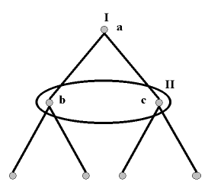

- The circled nodes are an "information set".
- Player 2 must make a choice not knowing what player 1 has done.

"Solving" games: Nash equilibria

- John Nash (1950): a solution to a game is a set of strategies where no player is tempted to deviate.
- Nobody can, through a unilateral change in strategy, get any more utility than what they're getting now.
- "Rational" players will reason the same way and get to one of these equilibria.

- Look at the payoff matrix again:

 | Defect | Cooperate
Defect | (2,2) | (4,0)
Cooperate | (0,4) | (3,3)

- C-C may look tempting, but each player has an incentive to switch strategies to D, as 4 > 3.
- C-D and D-C are no good as the player getting exploited has an incentive to switch (2 > 0).
- Only D-D is a Nash equilibrium. (This was seen by many as a depressing result!)

Evolution and game theory

- John Maynard Smith (1982): can we apply game theory to problems concerning the evolution of animal behaviour?
- No need to consider rational deliberation over strategies.
- A population of individuals repeatedly play games over evolutionary time: all sorts of different strategies are present initially.
- By standard evolutionary logic, strategies that do well will tend to become more prevalent: biological fitness is our utility function.
- When the population reaches a stable state, which strategies will be present?

Games in the biological world

- Contests over resources.
- Mate choice and sexual display.
- Sex ratio "decisions" by mothers.
- Parent-offspring conflict.
- Herding behaviour.
- Collective anti-predator vigilance and signalling.
- Reciprocal grooming.

The Hawk-Dove game

- Animals in a population must decide whether to be aggressive (Hawk) or passive (Dove) in resolving contests over resources.
- Two animals meet to contest a resource worth 10 units.
- Hawks always fight, Doves always surrender the resource.
- When two Hawks fight, the winner gets the resource but the loser is injured (-50 units). Each is equally likely to win or lose.
- A Hawk takes the resource from a Dove.
- Two Doves split the resource equally.

- The payoff matrix for the Hawk-Dove game:

 | Hawk | Dove
Hawk | (-20, -20) | (10, 0)
Dove | (0, 10) | (5, 5)

- Note that -20 is the average of +10 and -50.
- Where will the population end up? All Hawks? All Doves?

Two views of strategy evolution

- Approach 1: inspired by the Nash equilibrium concept, focus on the stable states of the population.
- Over evolutionary time, we should end up at a stable state so this is a reasonable simplification.
- Approach 2: treat the competing strategies as part of a dynamical system and study the trajectory through state-space.

Evolutionarily stable strategies

- A strategy is an ESS if no mutant could invade a population playing that strategy.
- Call the population strategy S and the mutant strategy M.
- F(X,Y) is the fitness expected by an animal playing X meeting an animal playing Y.
- S is an ESS if F(S,S) > F(S,M) (i.e., S is a "best reply" to itself).
- Or, if F(S,S) = F(S,M) but F(S,M) > F(M,M).

 | Hawk | Dove
Hawk | -20 | 10
Dove | 0 | 5

- Hawk cannot be an ESS: Hawks meeting Hawks expect a payoff of -20, but a Dove mutant would get 0 against Hawks and could therefore invade.
- Dove cannot be an ESS: Doves meeting Doves expect 5, but a Hawk mutant would get 10 against Doves and could thus invade.
- There is no ESS in the Hawk-Dove game if we are limited to "pure strategies". So a real population would have both Hawks and Doves. Can we say any more than this?

Mixed strategy equilibria

- What if the animals can randomize their strategies, playing Hawk some of the time and Dove the rest of the time?
- This expansion of the strategy space changes things.
- Assume there is an ESS where animals play Hawk with probability p and Dove with probability (1-p).
- At this ESS there must be no temptation to play either strategy a little more often, or that's where the population would go.
- We are therefore looking for a value of p where the expected payoffs for playing Hawk and for playing Dove are the same.

- Expected payoff for playing Hawk = (p)(-20) + (1-p)(10), because I will meet a Hawk (p) times and a Dove (1-p) times.
- Expected payoff for playing Dove = (p)(0) + (1-p)(5)... same logic.
- Set the two expected payoffs equal and solve for p:
  - -20p + 10 - 10p = 5 - 5p
  - p = -5 / -25
  - p = 0.2.
- So the ESS is a mixed strategy equilibrium where the animals play Hawk 20% of the time and Dove 80% of the time.
- This could also be interpreted as a polymorphic population: 20% Hawks and 80% Doves.

The replicator dynamics

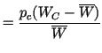
- A system of differential equations describing the change in the frequency of strategies over time.
- The rate of change of a strategy's frequency is proportional to its frequency multiplied by its relative difference from average fitness.
- In the Hawk-Dove game the predictions are the same, but this is not always so as trajectories can be complex.

Advantages of evolutionary game theory

- The evolutionary process does not have to be biological: it could be a model of learning or of cultural evolution.
- There is no need for debates on how to define a "rational player". Strategies persist if they do well.
- Ironically these two factors have meant that evolutionary game theory is now applied in areas like economics.
- There is room to move beyond the static equilibrium focus of traditional game theory, through the replicator dynamics.

Repeated games

- Games like the Prisoner's Dilemma can be very different, strategically, if they are played repeatedly by the same players, and those players can remember the results of previous rounds.
- The equilibria of a repeated game may be very different from those of its single-shot version.

Correlated play and spatial games
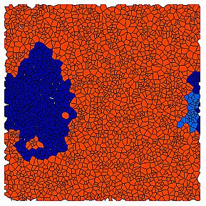
- A prisoner's dilemma, cooperators in red, defectors in blue.
- Play in a two-dimensional space means that you are more likely to encounter a genetic relative who plays the same strategy as you.
- This makes it possible for cooperation to survive.
- Image from Flache & Hegselmann (2001), JASSS.

Bibliography

Alexander, J. M. (2008). "Evolutionary game theory", The Stanford Encyclopedia of Philosophy, E. N. Zalta (ed.), URL = <http://plato.stanford.edu/archives/win2008/entries/game-evolutionary/>.

Binmore, K. (1992). Fun and Games: A Text on Game Theory. Heath, Lexington MA.

Maynard Smith, J. (1982). Evolution and the Theory of Games. Cambridge University Press.

Ross, D. (2008). "Game theory", The Stanford Encyclopedia of Philosophy, E. N. Zalta (ed.), URL = <http://plato.stanford.edu/archives/win2008/entries/game-theory/>.

von Neumann, J., & Morgenstern, O. (1947). Theory of Games and Economic Behavior. (2nd edn.) Princeton University Press.

